Architecture Documentation

CS 459: Software Engineering Senior Project

Spring 2025

| Project Title | HCAR Client Database |
| --- | --- |
| Sponsoring Company | Humboldt Community Access and Resource Center |
| Sponsor(s) | Pennie Lee, Kim Nash, Wes Patterson |
| Students | 1. [Orlando Trujillo-Ortiz](mailto:ot26@humboldt.edu) 2. [Carson Gustafson](mailto:cjg107@humboldt.edu) 3. [Justin Crittenden](mailto:jlc246@humboldt.edu) 4. [Michael Goodwyn](mailto:mjg165@humboldt.edu) |

Last Modified: 3/13/2025

# ABSTRACT

This document serves as the architecture documentation for the HCAR Client Database System.

# TABLE OF CONTENTS

**ABSTRACT 2**

**TABLE OF CONTENTS 2**

**LIST OF FIGURES 2**

**LIST OF TABLES 2**

**1. INTRODUCTION 2**

**2. ARCHITECTURAL STYLE USED 3**

**3. ARCHITECTURAL MODEL 4**

**4. TECHNOLOGY, SOFTWARE, AND HARDWARE USED 4**

4.1. Cloud Web Server 4

4.2. Cloud MySQL Database 5

4.3. Integration with Nylex Database / Cloud Storage Database 5

4.4. Miscellaneous Software Technologies 5

**5. RATIONALE 5**

**6. TRACEABILITY 5**

**7. CONFIGURATION MANAGEMENT 5**

**8. ENGINEERING STANDARDS AND CONSTRAINTS 6**

**9. ADDITIONAL REFEREN-CES 6**

# LIST OF FIGURES

1. HCAR Client Database Architectural Block Diagram

# LIST OF TABLES

# INTRODUCTION

The Humboldt Community Access and Resource Center (HCAR) Client Database System will be implemented as a web application with a database. The system will be composed of a Presentation Tier, an Application Tier, and a Data Tier. Planning and development of the system will be performed by [Orlando Trujillo-Ortiz](mailto:ot26@humboldt.edu), [Carson Gustafson](mailto:cjg107@humboldt.edu), [Justin Crittenden](mailto:jlc246@humboldt.edu), and [Michael Goodwyn](mailto:mjg165@humboldt.edu) (collectively, “The Team”).

The mission of this document is to describe in high-level detail the system architecture for the HCAR Client Database (“The System”). A description of the architectural style will be provided, along with rationale for its usage. Proceeding that will be an architecture diagram depicting the 3-tier architecture. There will also be a description of any technologies involved along with valid rationales for each decision. Lastly, there will be some detail into the project accountability process being used.

# ARCHITECTURAL STYLE USED

The HCAR Client Database is based on a classic 3-tier Web Application architecture. The first tier is the Presentation Tier, which is the visual subsystem that a user interacts with via the Internet. It will be grounded upon a traditional HTML, CSS, and JavaScript backbone. The Presentation layer is limited to only controlling the Graphical User Interface that a member of HCAR staff would access from their own web browser.

The second tier is the Application Tier, which resides on the HCAR Client Database Cloud Web Server. This subsystem is responsible for interpreting the queries submitted by users of The System and requesting the relevant data from the Cloud. HCAR business rules will be enforced for The System via this subsystem. The backend for the Web Server will be built using PHP language.

The third and final tier is the Data Tier, which comprises the two data sources for The System. With the condition that the appropriate third party can provide The Team with an Application Programming Interface (“API”), The System will utilize HCAR’s current Cloud Storage solution with Nylex. Otherwise, The System shall contract with a different third party Cloud Storage provider.

# ARCHITECTURAL MODEL

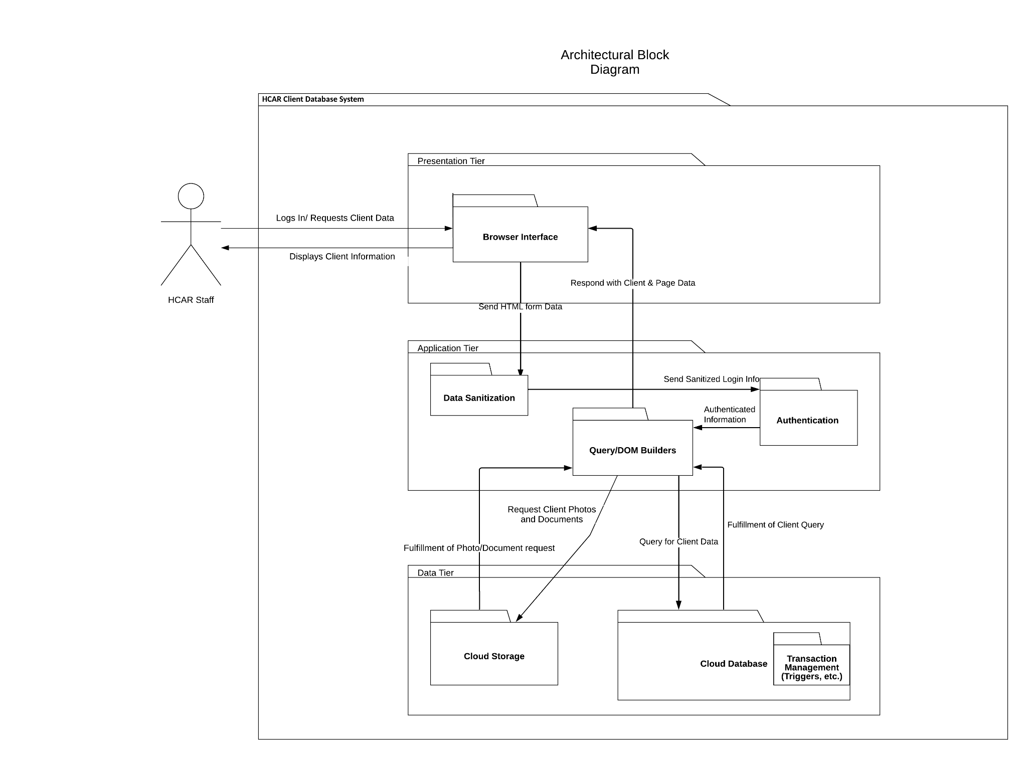

Fig. 1. HCAR Client Database Architectural Block Diagram

# TECHNOLOGY, SOFTWARE, AND HARDWARE USED

## Cloud Web Server

This project uses a Cloud Web Server to host the HCAR Client Database System. The web server is maintained by the Cloud Provider and does not need any infrastructure management. Said server is located remotely in a facility run by the Cloud Provider. The web server will host The System’s public-facing HTML/CSS/JavaScript so that HCAR staff users will be able to access The System’s Internet website from any Internet browser that supports modern web-standards.

## Cloud MySQL Database

This project uses a Cloud MySQL Database (“Database”) to store Client data. The Database is maintained by the Cloud Provider and is located in a secure location run by the Cloud Provider. The Database has a MySQL Relational Database Management System installed that can be interacted with via an API by the Cloud Web Server. When a User sends a request for a Client’s records, the Cloud Web Server will receive said request and then subsequently send an appropriately formatted query to the Database

## Integration with Nylex Database / Cloud Storage Database

This project will either integrate with HCAR’s current storage solution with Nylex or with a separate Cloud Storage solution provided by the same Cloud Provider for the Database. Regardless of the option finalized, the Cloud Storage will be utilized to centralize the storage of Client-related documents. Each file on the Cloud Storage will be kept track of in the Database. Upon a User’s request for the list of documents related to a Client, the Web Server will first query the Database for such a list of documents using an API. Once said list is acquired, the Web Server will be able to query the Cloud Storage for any particular document that is associated with the current Client by using a separate API.

## Miscellaneous Software Technologies

* + 1. HTML – HyperText Markup Language
    2. CSS – Cascading Style Sheets
    3. JavaScript
    4. PHP
    5. MySQL
    6. Google Cloud

# RATIONALE

WIP

# TRACEABILITY

| User Story | Subsystem |
| --- | --- |
| US1: As a staff member, I want to be able to view client demographics and non-medical information to better serve our clients. |  |
| US2: As a staff member, I want to be able to add new clients to the database so that we can securely record client information. |  |
| US3: As a staff member, I’d like to be able to upload my client documents in one location for convenience and so that I can see all my client’s information in one place. |  |
| US4: As a staff member, I’d like to be able to view my client's documents in one location for convenience and so that I can see all my client’s information in one place. |  |
| US5: As a staff member, I’d like for the purchase of the service date of expiration to notify me (or turn red) in some way when it is getting close to expiring, so I can avoid missing this date and safely obtain another purchase of services in a timely manner. |  |
| US6: As a staff member, I want to be able to write/upload case notes so that staff assigned to that client can be better informed about said client. |  |
| US7: As a staff member, I want to be able to review case notes so that myself and others can be better informed about our clients. |  |
| US8: As a staff member, I want to be able to log into the program so that I can keep client data securely protected. |  |
| US9: As a staff member, I want the program to automatically log me out of the system if I am inactive for 5 minutes, to prevent other people from using my account while I am away. |  |
| US10: As a staff member, I want to filter the client list by Program, Purchase of Service expiration date, and by client demographics such as name, address, and program/service code so I can reach a specific client. |  |
| US11: As a staff member, I want to be able to recover my account in case I forget my password, so I can continue using my designated account. |  |
| US12: As a staff member, I would like my reports to be customizable with a list of checkboxes for each information field, so when I go to export the data as a PDF I am given the requested fields. |  |
| US13: As a Manager, I want to have a higher access level to the system that allows me to manage and control staff/directors in lower access tiers, so some sensitive business information and abilities can be blocked from the other users of the system. |  |
| US14: As a Manager, I want to be able to see edit history for a client my colleague recently modified, so that I can hold my colleague accountable for any mistakes they make and reduce the amount of errors in client files. |  |

# CONFIGURATION MANAGEMENT

WIP

# ENGINEERING STANDARDS AND CONSTRAINTS

WIP

# ADDITIONAL REFERENCES

WIP